MACH4METAL

metalworking machinery
Transito 21
6909 DA BABBERICH Netherlands
Tel. +31 (0)316-247123
info@mach4metal.com
www.mach4metal.com

Bank No : 66.52.13.883
IBAN : NL33 INGB 0665 2138 83
BIC : INGBNL2A

MILLUTENSIL Try out DIE Spotting
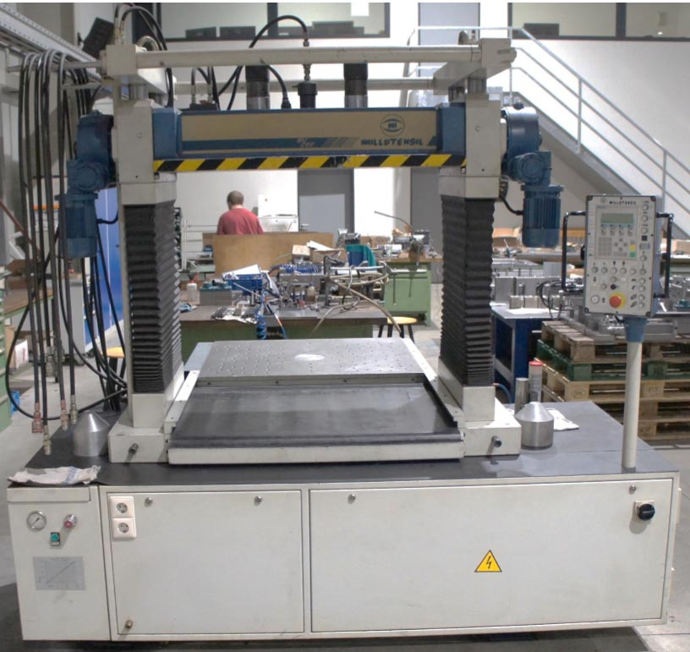
- Make : Millutensil ITALIA
- Typ : BV 26 E
- Mach.No : 247
- Age : 2002

- Capacity (Kg) : 30.000
- Table length : 850
- Table width : 980

- Min. distance tables : 320
- Max. distance tables : 920
- Vert. movement : 600
- Max. width : 1.080

- Table load : 4.000 Kg
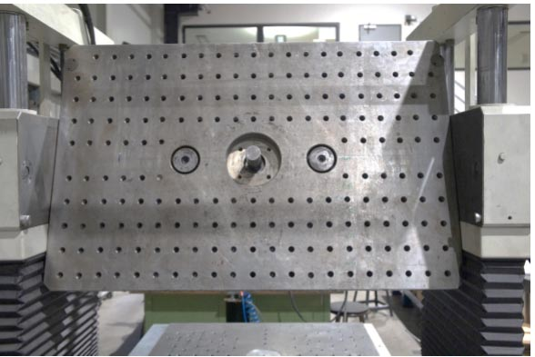
- Upper plate : 360˚
- Movement speed : 16 mm/Sec

- Dimensions

- Length : 2.350
- Width : 1.400
- Height : 2.430
- Weight : 3.750

- Lower table in & out
- Four guide column
- Single shot energy accumulator

Please Note: The above information has been obtained to the best of our ability and belief from, and from the manufacturers where possible. It is given in good faith, but its accuracy can not be guaranteed. Accordingly, it will not form a representation or constitute contractual terms. We advise you to check any vital details!

